https://www.hackerrank.com/challenges/printing-pattern-2/problem

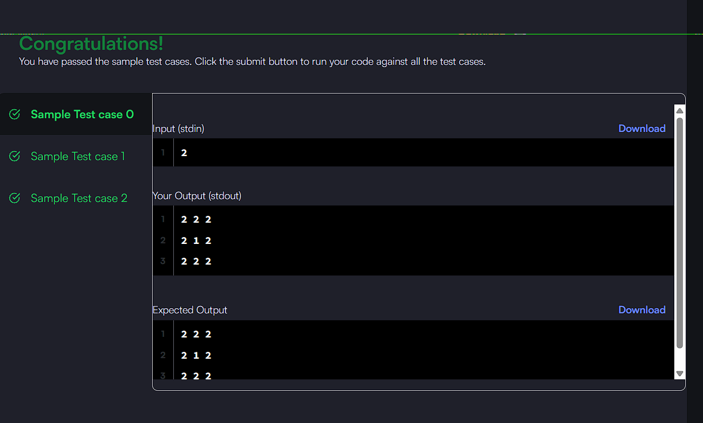

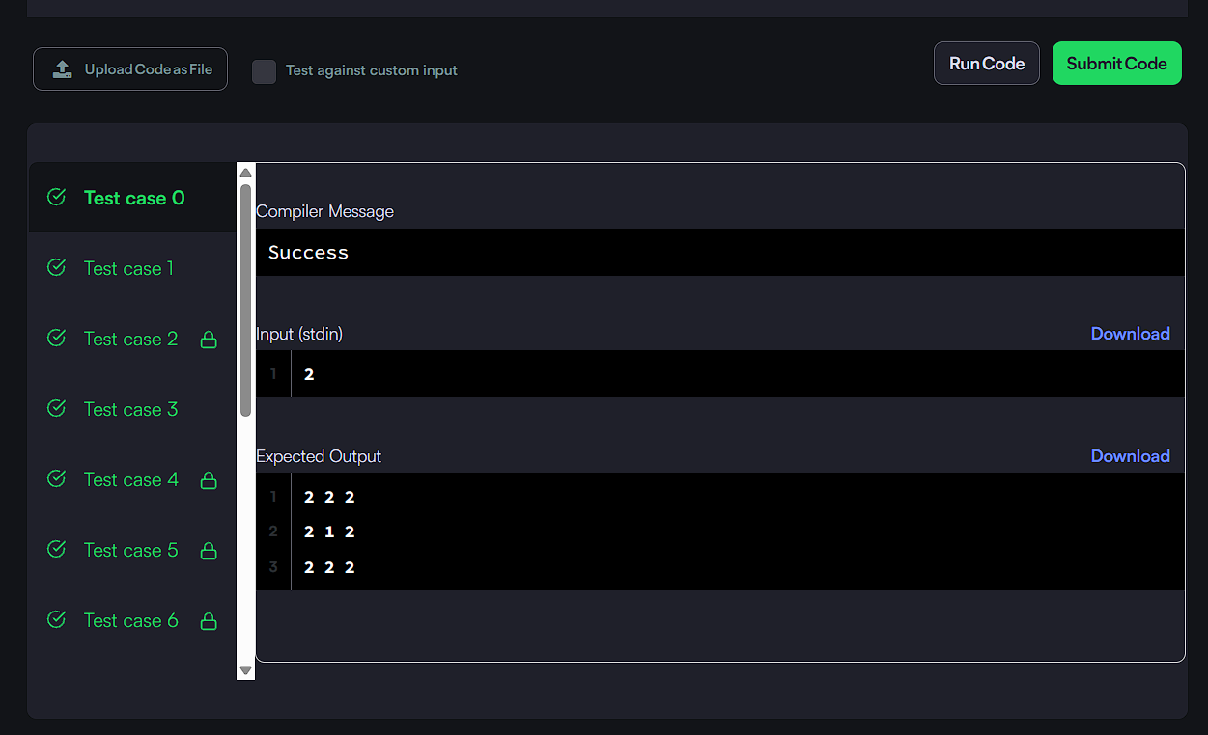

CODE:
int size = 2 * n - 1;

for (int i = 0; i < size; i++) {
for (int j = 0; j < size; j++) {
int top = i;
int left = j;
int bottom = size - 1 - i;
int right = size - 1 - j;

int min = top;
if (left < min) min = left;
if (bottom < min) min = bottom;
if (right < min) min = right;

printf("%d", n - min);
if (j < size - 1) {
printf(" ");
}
}
printf("\n");
}

